
ISTANBUL GELISIM UNIVERSITY
FACULTY OF ENGINEERING AND ARCHITECTURE
DEPARTMENT OF CIVIL ENGINEERING

GRADUATION THESIS
SPELLING DICTIONARY

1) STYLISTIC RULES OF GRADUATION THESIS

Paper size: A4
Margins: Top: 2.5 cm, Bottom: 2 cm, Left: 3 cm, Right: 2 cm.
Font type: Times New Roman / 12 font size (unless otherwise indicated).
Line gap: 1,5 line.
Page numbers: Under the page and in the middle (unless otherwise indicated)
Chapter headings: In the middle, all capital letters, 12 points, bold, numeration
is "1 INTRODUCTION".
Subtitles: Left-justified, only the first letter of the first word is capital, the other letters and words are lowercase, 12 point, bold, numbering is "2.1 Subtitle". It will be up to the 3rd rank (like 2.1.1.)
Paragraph format: Paragraph texts should be left and right justified. The start of line of the paragraph is not started from inside.
Paragraph spacing: There must be a line spacing between paragraphs. Before a new subheading, there must be two, then a line space.
Sections: Each (main) section should start from a new page.

2) LAYOUT OF GRADUATION THESIS

The Graduation thesis should be prepared in the following order.
Outer cover
Inner cover page
Front pages
- Preface
- Contents
- List of figures
- List of charts
- Abreviations
- Summary
Graduation Thesis
- Introduction
- Material and Method
- Application (Field) Study
- Results
Last Pages
- Thank
- References
- Attachments
The explanations about the layout of the Graduation Study are below.
OUTER COVER
The outer cover should be bound with white coated cardboard. An example of an outer cover is given below.
INNER COVER PAGE
The content and layout should be the same as the outer cover. The page number is not displayed on the inner cover. The example is attached.

FRONT PAGES

PREFACE contains explanations and acknowledgments about the Graduation Work. The page number is shown in Roman format, at the bottom of the page and in the middle. The following front pages are similarly numbered in Roman numerals, respectively.

CONTENTS contains the titles of the front pages, the chapters and subdivision titles of the working text, and the titles of the last pages which are given with page numbers. The page number appears at the bottom of the page.

LIST OF FIGURES states the figures used in the study , showing the "figure number, name and page number". The page number appears at the bottom of the page.

SCHEDULE LIST the charts used in the study are listed under this heading, showing the "table number, name and page number". The page number appears at the bottom of the page.

ABBREVIATIONS The explanations of all abbreviations made in the text will be included here.

SUMMARY Under the this title should be a summary of the study, not more than one page. In the summary, the problem addressed should be introduced, the study followed and the method of data collection should be briefly explained and the results obtained should be mentioned. In addition, sections of the study should be briefly introduced. The page number appears at the bottom of the page.

GRADUATION THESIS

INTRODUCTION Under the this title , previous studies on the subject of the study, the purpose and scope of the research and the method used should be clearly stated. If necessary, previous studies can be given in the main text. Beginning from 1, each page is given a number starting from the Introduction Section; numbers are displayed at the bottom of each page and in normal numbers.

The main text of the study is the part between the INTRODUCTION and RESULTS sections. It consists of chapters and sub-sections according to the nature of the subject, Material and Method used, Application, Field Study Findings and detail of the study.

RESULTS The results obtained from the graduation work under the results heading should be written as concise and clear as possible. If the results achieved need to be compared and discussed with previous studies and results, this should be written under the RESULTS and DISCUSSION heading. If there are suggestions that the researcher wishes to convey to the relevant parties, the RESULTS and SUGGESTIONS title can be used.

LAST PAGES

REFERENCES, publications referred to in the working text (referred to). The list of these publications should be given in alphabetical order according to the surname of the author. REFERENCES title is written centered and the section number is not given.

- ATTACHMENTS ,information that is not required to be included in the text, layouts that are larger than the normal page and which are undesirable / impossible to shrink, etc. should be given under the this title. The title of ATTACHMENTS is written centered and the section number is not given.

3 GRADUATION THESIS WRITING RULES

General
The figures, charts, equations and footnotes are given below with examples as sub-sections.

Figures
The figures given below are arranged according to the following principles in the text:

• The figures should be mentioned / cited in the text and the figures should be placed close to the place in the text.

• The figure number and description should be written below the figure. One (1) line spacing should be used in the description.

• Figures should be numbered consecutively, starting with "1" in each section, with the first (main) section number. For example, the 9th version of chapter 3 should be written as “Figure 3.9”.

• A character space should be left after the figure description number, only the first letter of the leading word should be written in capital letters and the other letters and words should be written in lowercase letters.

• Figures and titles should be centered in the text.

• Figures taken from another publication must be cited at the end of the figure name.
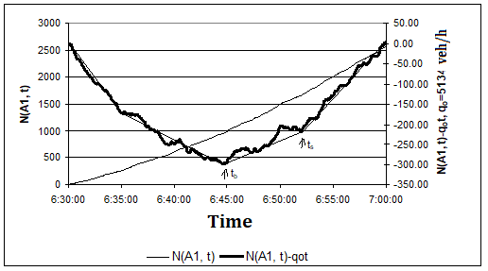
Figure 2.1 Scaled and unscaled accumulated number of vehicles curves.

Charts
The charts, of which an example is given below, are arranged in the text according to the following principles:
• Tables should be mentioned / cited in the text and the tables should be placed close to the place in the text.
• The table number and description should be written on the table. One (1) line spacing should be used in the description.
• Schedules should be numbered consecutively, starting with "1" in each section, with the first (main) section number. For example, the 7th chart of Chapter 4 should be written in the format of "Table 4.7".
• A character space should be left after the table description number, only the first letter of the leading word should be written in capital letters and the other letters and words should be written in lowercase letters.
• Schedules and titles should be centered in the text.
• For the tables taken from another publication, the source should be cited at the end of the table name.

Chart 3.1 Products and codes
Product Code | Product
101.010 | Compaq Deskpro EP
001.005 | Pentium II 400 512C
004.003 | 64 MB 168 Pin SDRAM
003.003 | 4.3 GB HDD
008.004 | 40x CDROM
007.003 | 4 MB Display card AGP
005.006 | 14” Digital Monitor

3.4 Equations (Equations, Relationships)

• Writing the equations should start from the left edge of the page.

• Equations must be numbered consecutively, starting with "1" in each section, with the first number as the section number. For example, the first equation of section 2 should be written in the format (2.1). Equation numbers must be written in parentheses at the end of the line. To do this, the cursor / curl is brought to the end of the typed formula; Clicking on the square shape located at the far left of the screen and at the level of the horizontal ruler at the top edge of the WORD page, the mouse shows the “┘” (inverted L) mark; then the tab shape is placed by clicking the mouse at the very end of the horizontal ruler - where you want the formula number to rest; If desired, the tab can be moved by dragging with the mouse; By pressing the tab key, the cursor is brought to the end of the line and the equation number is written.

• 1.5 line spacing should be left between the text and the equation (1 line break).

Example equation:
$5x^{2}+8\text{xy}+5y^{2}=9{\left(\frac{x+y}{\sqrt{2}}\right)}^{2}+{\left(\frac{x−y}{\sqrt{2}}\right)}^{2}$ (2.1)

Disclosures *

• Disclosures / Footnote option can be used in Add / Insert menu of WORD program to add footnotes. For this, the cursor is placed at the end of the word to add a Disclosures and Footnote is selected from the Insert menu.
• They must be specified in the format (*), (**) ... in the page they pass.
• It should be separated from the main text with a line at the end of the page (In the Footnote option, WORD puts this line by itself).
• The page should not overflow into the margins.
• A line spacing should be used in writing.
• Letter size should be 10 font.

3.6 References

All sources used in the study should be specified in the text in appropriate places and should be listed at the end of the study. All the sources mentioned in the list should be shown in the text. The ways in which a used resource is shown in the text are shown in the examples below:
Example 1:

As mentioned in Şahin (2001), density is the most difficult to obtain from the field among the main magnitudes of traffic flow.

Example 2:

Density is the most difficult to obtain from the field among the main magnitudes of the traffic flow (Şahin, 2001).

References should be listed in alphabetical order according to the surname of the first authors. A book, journal article, paper, lecture note, report, guide, etc. of the resource used. The way it is listed varies slightly. However, information such as author surname, name, publication year, source name, publisher name for each resource are among those listed. Below,there is an example of the SOURCES list.

REFERENCES

Gedizlioğlu, E. ve Akad, M. (1994) “Capacity Use on the Bosphorus Bridge and Its Approaches”, Proceedings of the Second International Symposium on Highway Capacity, Akçelik, R. (Ed.), Vol. 1, s. 223-242.

Cassidy, M.J. ve Mauch, M. (2001) “An Observed Traffic Pattern in Long Freeway Queues”, Transportation Research-A, Vol. 35, s. 143-156, Elsevier Science Ltd.

Şahin, İ. (2001) “İstanbul Boğaziçi Köprüsü Bağlantı Yollarında Kapasite Kullanım Düzeyinin Araştırılması”, 5. Ulaştırma Kongresi, İnşaat Mühendisleri Odası İstanbul Şubesi, Bildiriler Kitabı, s. 223-230.

Daganzo, C.F. (1997) “Fundamentals of Transportation and Traffic Operations”, Elsevier Science Ltd. ISBN 0 08 042785 5.

3.7 Project Sheet Layout (This section is taken from the previous spelling guide.)

Projects should be prepared in standard sheet sizes. These dimensions are given below.

A0 1188 x 840 mm
A1 840 x 594 mm
A2 594 x 420 mm

A3 420 x 297 mm
A4 297 x 210 mm

• Line thicknesses should be as follows.
Plan 4K 0.4 mm
Sections 8K 0.8 mm
Dimension lines 1.5 K 0.2 mm
Articles 2K 0.2-0.3 mm
Axis lines 2K 0.2 mm (A short long dashed line)
Cross section line 8K 0.8 mm (A short long dashed line
Section line 1K 0.1 mm (A short dashed line)

• Letterheads of A4 size, one of which is given at the end of this guidebook, should be created in the lower right corners of the project sheets. Sheet numbering on these letterheads should be given as follows.
X – XXX – X.XX – XX/XX
1 2 3 4 5 6
Project sequence number
Unit number (the last two digits of the student number)
Type no (01: General, 02: Reinforced Concrete, 03: Steel, 04: Architecture, 05:Hydraulics, 06: Soil)
Group no (I: Construction, M: Mechanical, E: Electric)
Field Code Name (KRF: Körfez, IZM: İzmit)
Project Sheet Size (A0, A1, etc.)

- • Projects should be prepared manually with the help of rapido or with the help of the Autcad program.
• Projects drawn on tracing paper should be rolled, blueprints should be folded in A4 norm with the first face letterhead visible and added at the end of the report. Project letterhead, exemplified below, should be placed in the lower right corner of the sheet in A4 size.

Project letterhead example:

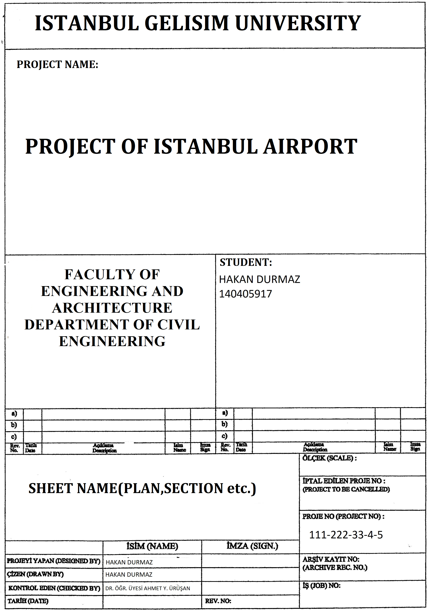

4 SOME WRITING RULES

- • The punctuation marks are placed right after the end of the word without any spaces, and then the text is continued by leaving a space character.
- • Paragraphs are parts of text that have integrity in themselves. The first sentence of each paragraph should provide preliminary information about the content of that paragraph.
- • Do not use first person subject (I). Instead, choose to use “We”; For example, it is more appropriate to use "we have / we will / we will" instead of "I have / will / I will." In addition, the passive structure is also used in scientific studies; for example, "done / done / will be done".
- Writing rules of the suffix “de” and of the word “de”

a) "-de", which is the suffix of the noun status, is written adjacent to the word following it; and it is adaptive to backness harmony:

Like ... on the train, on the road, in Istanbul.

b) As the conjunction "de" is a word in itself, it is written separately from the preceding word and fits the backness harmony according to the last vowel of the preceding word:

Railway is also one of the compulsory courses I should take.
He also missed the exam because he got sick.
I'm a civil engineer too.

- Quotes (“ ”)

a) In a text, it is put at the beginning and end of the text or words transferred from someone else:

Şahin (2001), one of the sources referring to this subject, states: “As a rule, the horizontal trend sections of the difference curve have the same current value as qo”.

b) It is put at the beginning and end of the words to be specified:

The main sizes of the traffic flow are "volume, density and speed".

- Colon (:)

It will be put at the end of this sentence or word if explanations are made after a sentence or word, and examples are given:

Some public transportation systems in Istanbul are as follows: Bus, Metro, Tram, City Lines Ferry ...

- Semicolon (;)

- a) It is used to separate sentences that are interdependent, but each one is independent: “The transportation planning of a region is multidimensional; the demographic characteristics of the region are effective on mobility; land use policy is another effective factor. ”
- b) It is used to separate equal parts that have commas between them: “Horizontal curves, tangent (alignment), easement curve horizontal; vertical curves, longitudinal slope are vertical geometric elements. ”
- If the two sentences are connected to each other with conjunctions such as "but, because, only ...", a semicolon is put after the first sentence: "To graduate, all courses must be successful; however, the GPA must be at least C (2.0). ”

OUTER COVER:

ISTANBUL GELISIM UNIVERSITY
FACULTY OF ENGINEERING AND ARCHITECTURE
DEPARTMENT OF CIVIL ENGINEERING

SUBJECT OF GRADUATION THESIS

Name Surname
Student No

Studied in the Department of xxx

GRADUATION THESIS
Advisor: Appelation Name Surname

ISTANBUL, 20XX

* Example Footnote

